**Project: Gift Planner**

**By team: L.A.P**, group 6

Lucas Murdock – 200304037

Adam McNown – 200427796

Parth Bhavesh Kumar Bhatt – 200406685

**Project Overview**

We are Recreating our proposal since the original project was made not possible due to the fact that sleep easy needed access to sounds and the macs could not play sounds unless we were physically using the mac itself.

Gift Planner is an application that will allow users to create a to-do list for special occasions and assign certain gifts to certain people. The purpose of the application is for user to use the to-do list to help plan out holidays and gift giving easier.

Our team will be using the BA-A251 Mac Lab computers running Xcode version 11.3.1 to design, build and run our application using Swift. We will also use various free images websites to help with the design and look of the application.

For communication with team members we will be using Slack, which we have set up a group for our team, and WebEx for when we need to discuss things more in depth. We have proven to communicate on a regular basis, and we will continue to stay well in touch throughout the process of our Gift Planner project.

**Functional Requirements / Use Cases**

The Gift Planner application will have a number of features which are outline in point form below and can be seen in figure 1 and 2 in our project design portion:

* Home screen will feature a button to enter the main application.
* Upon clicking button users will move to the event screen which will feature what is currently recorded by the user:
* Add Event will feature 2 text boxes and a date picker for user to add information about the event and a button at the bottom for adding the event.
* You can also click on previously made events to then add items, price, and location to the person for what gifts they want.

**Project Design**

Figure 1: basic flow diagram for application

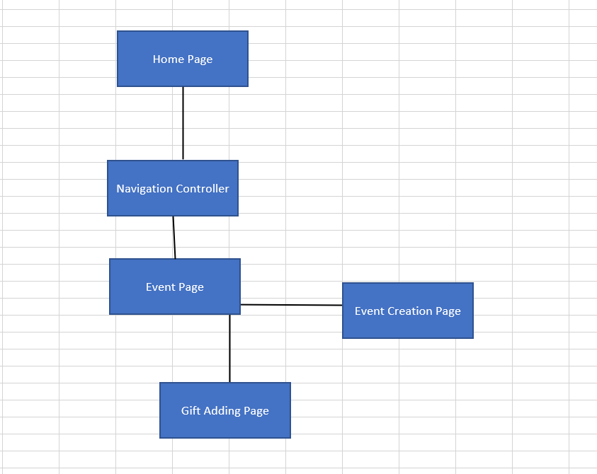

Figure 2: Basic design of application screens

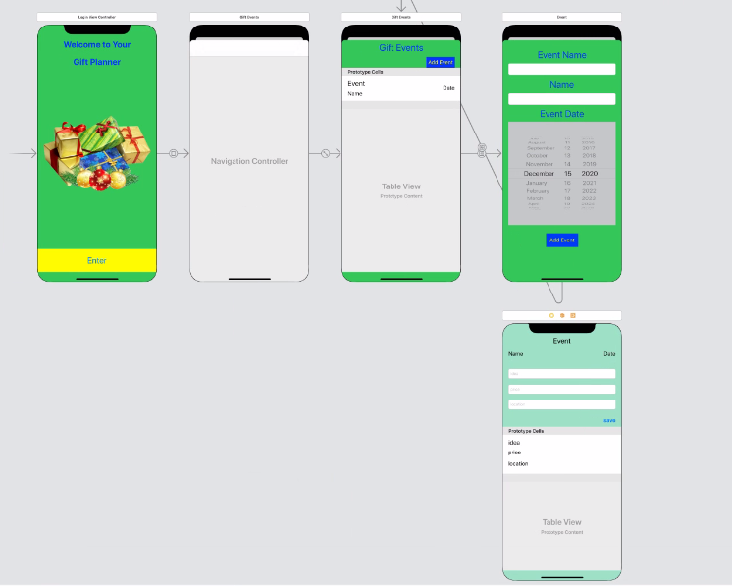

**Work Assignments**

This is the layout of our team’s roles and who is responsible for what key aspects:

* Home screen design– Adam McNown
* Event page – Ownership: Adam McNown
* Adding an event page – Ownership: Luke Murdock:
* Gift page – Ownership: Parth Bhavesh Kumar Bhatt
* Re-Creating Proposal – Ownership: Luke Murdock
* Video presentation – Ownership: Group

The Swift Classes we will use will be:

* Event Add Class: Would Add event to database when user adds information and clicks add. Ownership: Luke Murdock
* Event Page/Database: Displays database information in a user-friendly manner. Ownership: Adam McNown
* Gift Detail Class/Database: Displays each person’s gift list and allows users to add to it. Ownership: Parth Bhavesh Kumar Bhatt